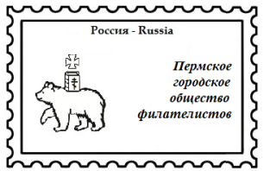ПЕРМСКОЕ ГОРОДСКОЕ ОБЩЕСТВО ФИЛАТЕЛИСТОВ
www.sfr-perm.ru
Адрес: 614015 Пермь, ул. Пермская, д. 37, оф. 6.
E-mail: ofilatelistov@mail.ru

The Perm Philatelic Society / www.sfr-perm.ru / Address: 614015 Russia, Perm, Permskaya st. 37, of. 6.

Application form
“FinnoUgoria Open’18”
Town of Cherdyn, Perm Region
11/06 – 30/06 2018.

Name: ___________________________________________________________

Postal Address: ___________________________________________________

E-mail: __________________________________________________________

Name of the Exhibit:
____________________________________________________________________________________________________________________________________

Class: __________________

Summary:
____________________________________________________________________________________________________________________________________
____________________________________________________________________________________________________________________________________

Pages: 12, 24, 36, 48, 60
(underline)

Date:

Signature:

Organizing Committee: ofilatelistov@mail.ru / www.sfr-perm.ru

